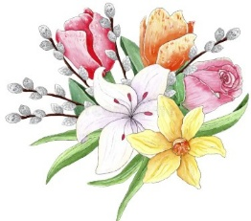

In Memory of: In Honor of:

Our Parents Our nine grandchildren
by Ted and Karen Kopp by Wayne and Alana Frazier

My Parents Our children and grandchildren
Ralph & Greta Dickerson Michael, Matthew, Jessica
by Sonja Cole Albury, Mackenzie, Liliana, and Lincoln
by Doug and Mindy Ward
Paul Lehman
by Carol DeZorzi Our grandchildren
Rylie, Reagan, Trevor
Joey Vaughan Carmyn, & Carly
Phyllis & Joe Vaughan by Susan & Dane Swenson
by Clorese Vaughan

Amy Elizabeth Monahan
by Mary Virginia & Stan Polonsky

John & Elizabeth Swenson
Paul & Jo Witherow
by Susan & Dane Swenson

Our brother
Scott McAlexander
by Hope & Roy Saettel

In Memory of: In Honor of:

Our Parents Our nine grandchildren
by Ted and Karen Kopp by Wayne and Alana Frazier

My Parents Our children and grandchildren
Ralph & Greta Dickerson Michael, Matthew, Jessica
by Sonja Cole Albury, Mackenzie, Liliana, and Lincoln
by Doug and Mindy Ward
Paul Lehman
by Carol DeZorzi Our grandchildren
Rylie, Reagan, Trevor
Joey Vaughan Carmyn, & Carly
Phyllis & Joe Vaughan by Susan & Dane Swenson
by Clorese Vaughan

Amy Elizabeth Monahan
by Mary Virginia & Stan Polonsky

John & Elizabeth Swenson
Paul & Jo Witherow
by Susan & Dane Swenson

Our brother
Scott McAlexander
by Hope & Roy Saettel

